1. **Define cloud computing.**

**cloud computing is the delivery of computing services—including servers, storage, databases, networking,**

**software, analytics, and intelligence—over the internet (“the cloud”) to offer faster innovation, flexible**

**resources, and economies of scale.**

**Fig. Cloud Computing**

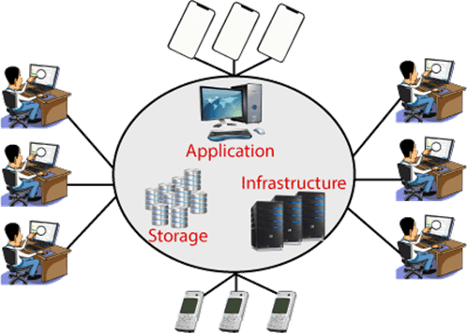

**• Cloud Computing provides an alternative to the on-premises datacenter.**

**• With an on-premises datacenter, we have to manage everything, such as purchasing and installing**

**hardware, virtualization, installing the operating system, and any other required applications, setting up**

**the network, configuring the firewall, and setting up storage for data.**

**• After doing all the set-up, we become responsible for maintaining it through its entire lifecycle.**

**• But if we choose Cloud Computing, a cloud vendor isresponsible for the hardware purchase and**

**maintenance.**

**• They also provide a wide variety of software and platform as a service.**

**• We can take any required services on rent.**

**• The cloud computing services will be charged based on usage.**

**• The cloud environment provides an easily accessible online portal that makes handy for the user to**

**manage the compute, storage, network, and application resources.**

1. **Types of cloud.**

Following are the four types of Cloud Deployment Models identified by NIST.

1. Private Cloud
2. Community Cloud
3. Public Cloud
4. Hybrid Cloud

# **1.** **Private Cloud**

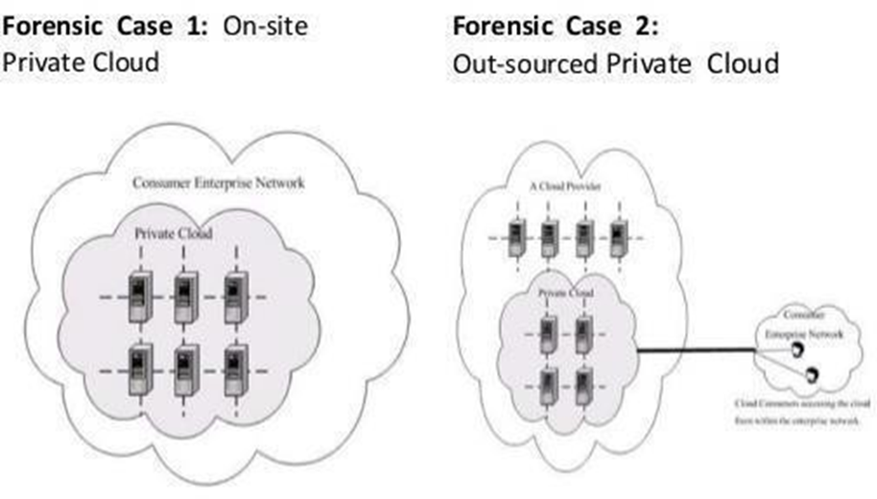

* + The cloud infrastructure is operated solely for an organization.
  + Contrary to popular belief, private cloud may exist off premises and can be managed by a third party. Thus, two private cloud scenarios exist, as follows:

### **On-site Private Cloud**

* + Applies to private clouds implemented at a customer’s premises.

### **Outsourced Private Cloud**

* + Applies to private clouds where the server side is outsourced to a hosting company.

### **Examples of Private Cloud:**

* + Eucalyptus, Ubuntu Enterprise Cloud - UEC (powered by Eucalyptus), Amazon VPC (Virtual Private Cloud), VMware Cloud Infrastructure Suite, Microsoft ECI data center etc.

# **2.** **Community Cloud**

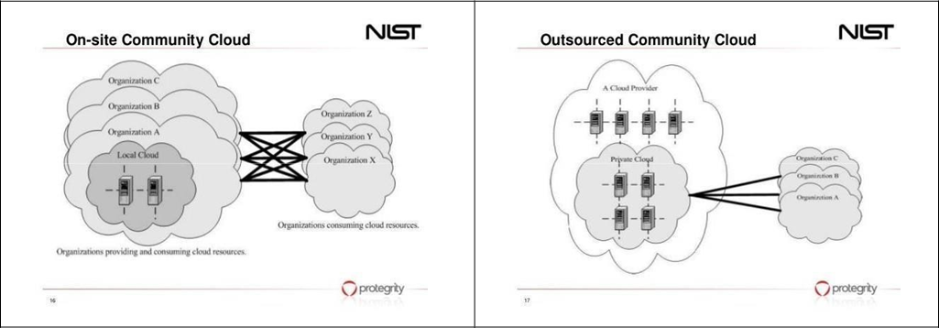

* + The cloud infrastructure is shared by several organizations and supports a specific community that has shared concerns (e.g., mission, security requirements, policy, and compliance considerations).
  + Government departments, universities, central banks etc. often find this type of cloud useful.
  + Community cloud also has two possible scenarios:

### **On-site Community Cloud Scenario**

* + Applies to community clouds implemented on the premises of the customers composing a community cloud.

### **Outsourced Community Cloud**

* + Applies to community clouds where the server side is outsourced to a hosting company.

### **Examples of Community Cloud:**

* + Google Apps for Government, Microsoft Government Community Cloud, etc.

# **3.** **Public Cloud**

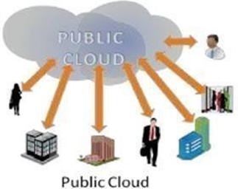

* + The most ubiquitous, and almost a synonym for, cloud computing.
  + The cloud infrastructure is made available to the general public or a large industry group and is owned by an organization selling cloud services.

### **Examples of Public Cloud:**

* + Google App Engine, Microsoft Windows Azure, IBM Smart Cloud, Amazon EC2, etc.

# **4.** **Hybrid Cloud**

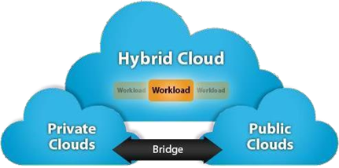

* + The cloud infrastructure is a composition of two or more clouds (private, community, or public) that remain unique entities but are bound together by standardized or proprietary technology that enables data and application portability (e.g., cloud bursting for load-balancing between clouds).

### **Examples of Hybrid Cloud:**

* + Windows Azure (capable of Hybrid Cloud), VMware vCloud (Hybrid Cloud Services), etc.

1. **Describe advantage and disadvantages of cloud computing.**

# Ø **Advantages of Cloud Computing**

* **Cost:** It reduces the huge capital costs of buying hardware and software.
* **Speed:** Resources can be accessed in minutes, typically within afew clicks.
* **Scalability:** We can increase or decrease the requirement of resources according to the business requirements.
* **Productivity:** While using cloud computing, we put less operational effort. We do not need to apply patching, as well as no need to maintain hardware and software. So, in this way, the IT team can be more productive and focus on achieving business goals.
* **Reliability:** Backup and recovery of data are less expensive and very fast for business continuity.
* **Security:** Many cloud vendors offer a broad set of policies, technologies, and controls that strengthen our data security.

# Ø **Disadvantages of Cloud Computing**

* + **Requires good speed internet with good bandwidth**: To access your cloud services, you need to have a good internet connection always with good bandwidth to upload or download files to/from the cloud
  + **Downtime**: Since the cloud requires high internet speed and good bandwidth, there is always a possibility of service outage, which can result in business downtime. Today, no business can afford revenue or business loss due to downtime or slow down from an interruption in critical business processes.
  + **Limited control of infrastructure**: Since you are not the owner of the infrastructure of the cloud, hence you don’t have any control or have limited access to the cloud infra.
  + **Restricted or limited flexibility**: The cloud provides a huge list of services, but consuming them comes with a lot of restrictions and limited flexibility for your applications or developments. Also, platform dependency or ‘vendor lock-in’ can sometimes make it difficult for you to migrate from one provider to another.
  + **Ongoing costs**: Although you save your cost of spending on whole infrastructure and its management, on the cloud, you need to keep paying for services as long as you use them. But in traditional methods, you only need to invest once.
  + **Security**: Security of data is a big concern for everyone. Since the public cloud utilizes the internet, your data may become vulnerable. In the case of a public cloud, it depends on the cloud provider to take care of your data. So, before opting for cloud services, it is required that you find a provider who follows maximum compliance policies for data security.
  + **Vendor Lock-in**: Although the cloud service providers assure you that they will allow you to switch or migrate to any other service provider whenever you want, it is a very difficult process. You will find it complex to migrate all the cloud services from one service provider to another. During migration, you might end up facing compatibility, interoperability and support issues. To avoid these issues, many customers choose not to change the vendor.

**Technical issues**: Even if you are a tech whiz, the technical issues can occur, and everything can’t be resolved in-house. To avoid interruptions, you will need to contact your service provider for support. However, not every vendor provides 24/7 support to their clients.

1. **Explain Characteristics of cloud computing.**

The five essential characteristics of cloud computing:

1. **On-demand self-service:** A consumer can separately provision computing capabilities, such as server time and network storage, as needed automatically without requiring human interaction with each service provider.
2. **Broad network access:** Capabilities are available over the network and accessed through standard mechanisms that promote use by heterogeneous thin or thick client platforms (e.g., mobile phones, tablets, laptops and workstations).
3. **Resource pooling:** The provider's computing resources are pooled to serve multiple consumers using a multi-tenant model, with different physical and virtual resources dynamically assigned and reassigned according to consumer demand. There is a sense of location independence in that the customer has no

control or knowledge over the exact location of the provided resources but may be able to specify location at a higher level of abstraction (e.g., country, state or datacenter). Examples of resources include storage, processing, memory and network bandwidth.

1. **Rapid elasticity:** Capabilities can be elastically provisioned and released, in some cases automatically, to scale rapidly outward and inward matching with demand. To the consumer, the capabilities available for provisioning often appear to be unlimited and can be appropriated in any quantity at any time.
2. **Measured service:** Cloud systems automatically control and optimize resource use by leveraging a metering capability at some level of abstraction appropriate to the type of service (e.g., storage, processing, bandwidth and active user accounts). Resource usage can be monitored, controlled and reported, providing transparency for the provider and consumer.

* 1. What type of computing technology refers to services and applications that typically run on a distributed network through virtualized resources?

# **a.** **Cloud Computing**

* + 1. Soft Computing
    2. Parallel Computing
    3. Distributed Computing
  1. is the delivery of on-demand computing services, from application to storage and processing power, typically over the internet and on a pay-as-you-go basis.

# **a)** **Cloud computing**

1. Cloud Infrastructure
2. Distributed system
3. None of these2.
   1. Which of the following cloud concept is related to pooling and sharing of resources?
4. Polymorphism
5. Abstraction

# c) **Virtualization**

1. None of the mentioned 3.
   1. Which of the following is Cloud Platform by Amazon?
2. Azure

# **b)** **AWS**

1. Cloudera
2. All of the mentioned
   1. Which of the following is the deployment model?
3. public
4. private
5. hybrid

# **d)** **all of the mentioned**

* 1. Which of the following benefit is related to creates resources that are pooled together in a system that supports multi-tenant usage?

# **a)** **On-demand self-service**

1. Broad network access
2. Resource pooling
3. All of the mentioned
   1. Which of the following is the most important area of concern in cloud computing?

# **a)** **Security**

1. Storage c)Scalability

d) All of the mentioned

* 1. Elasticity in Cloud Computing is:

|  |  |
| --- | --- |
| a) | Ability to scale up |
| b) | Ability to scale down |
| **c)** | **A and B both** |
| d) | None of these |

* 1. Which is not a Cloud service option?

|  |  |
| --- | --- |
| **a)** | **VaaS** |
| b) | IaaS |
| c) | PaaS |
| d) | SaaS |

* 1. Which is not a Cloud deployment model?

|  |  |
| --- | --- |
| a) | Private Cloud |
| **b)** | **Software Cloud** |
| c) | Community Cloud |
| d) | Hybrid Cloud |

11.is an open-source software platform for implementing IaaS in a private or hybrid cloud computing environment.

|  |  |
| --- | --- |
| a) | [Windows Azure](https://gtu-mcq.com/BE/Computer-Engineering/Semester-8/2180712/5189/MCQs?q=9aZHDjblmRk%3D) |
| b) | Eclipse |
| **c)** | **Eucalyptus** |
| d) | None of these    **Write down a full form of following term.**   1. **IAAS :-** Infrastructure as a Service 2. **PAAS:-** Platform as a Service 3. **SAAS:-** Software as a Service 4. **CSM:-** Content Management System |